COMMUNITY FOREST MANAGEMENT PLAN
BjokaGongphelTsharzoTshogpa
(Management of Yula and Cane)
Gewog: Bjoka
Dzongkhag: Zhemgang
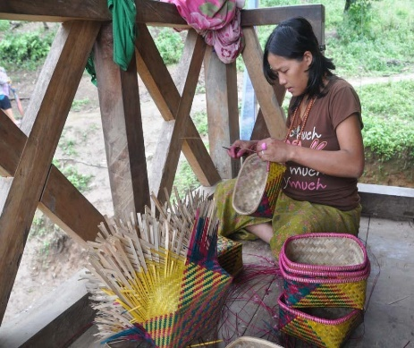
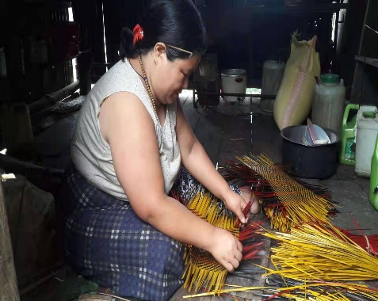

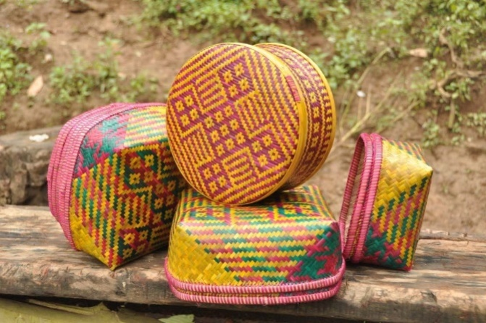

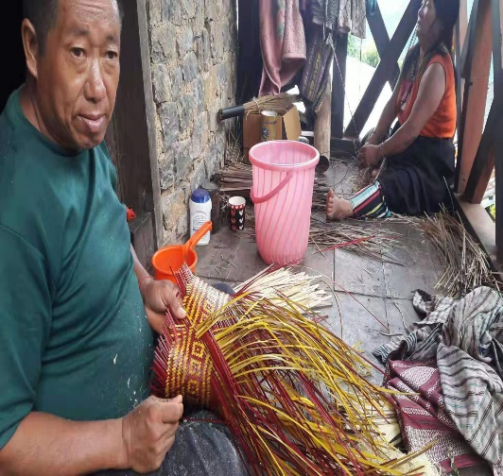
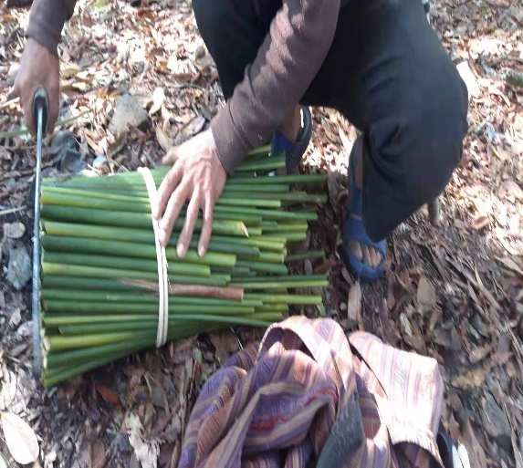

Plan Period: September 2019- August 2020

APPROVAL SHEET

Table of Contents

APPROVAL SHEET ii
Table of Contents iii
List of Tables vi
List of Figures vi
Acronyms vii
Executive Summary viii
Part I: Community Forest Management Plan (Yula and Cane Management) - 1 -
Introduction - 1 -
Objectives - 2 -
Community Forest Boundaries - 2 -
Social information - 2 -
Forest Information (whole Bjoka gewog) - 3 -
History of Forest - 4 -
Formation of Management Sub-Groups - 5 -
Block descriptions - 5 -
Brief description of Yula - 6 -
Management of Yula - 6 -
Description of Sub-Group - 7 -
Trong Sub-Group - 7 -
Kamati Sub-Group - 8 -
Barpong Sub-Group - 8 -
Chapdhempa Sub-Group - 9 -
Dali Sub-Group - 10 -
Demand Assessment of Yula - 10 -
Annual Harvest Limit (AHL) of Yula - 11 -
Comparison of Demand and AHL of Yula - 11 -
Yula harvesting guidelines - 11 -
Management of Cane - 12 -
Brief descriptions of Cane - 12 -
Calamus acanthospathus Error! Bookmark not defined.
Calamus latifolius Error! Bookmark not defined.
Plectocomia himalayana Error! Bookmark not defined.
Harvesting guidelines for cane stems - 13 -
Harvesting guidelines for cane shoots from Plectocomia himalayana only - 13 -
Location and boundary - 14 -
Sub Group for Management of Cane - 15 -
Demand Assessment of Cane - 15 -
Annual Harvesting Limit (AHL) of Cane - 16 -
Comparison of Demand and AHL of Cane - 16 -
Rules for collection and management of Cane - 17 -
Monitoring and Work Plan - 18 -
Part II: Community Forest Management By-Laws - 20 -
Membership Arrangements - 20 -
Procedures for becoming a new member - 20 -
Executive Committee Member Formation - 20 -
Procedures for selection of executive committee members - 21 -
Criteria for selection of executive committee members - 21 -
Roles and Responsibility of Executive Committee Members - 21 -
Terms of Reference (ToR) for CF Executive Committee Member - 22 -
ToR for Chairperson - 22 -
ToR for Secretary - 22 -
ToR for Treasurer - 23 -
ToR for Resoop - 23 -
Roles and Responsibility of CFMG members - 23 -
Compensation to Executive Committee Members - 24 -
Fines and Penalties - 24 -
Penalties and Fines for Yula - 24 -
Penalties and Fines for Cane - 25 -
Financial Arrangements - 25 -
Benefit Sharing Arrangements - 26 -
Arrangements for benefits to poor households - 26 -
Other benefit sharing arrangements - 26 -
Meetings - 27 -
Conflict Management - 27 -
Amendment of CFMP and By-laws - 27 -
Power of the Department - 27 -
Marketing of Products - 27 -
Procedures to bring products to collection center - 28 -
Support required from other stakeholder - 28 -
Forest Beat Office, Bjoka - 28 -
Zhemgang Forest Division - 29 -
Dzongkhag administration - 29 -
Gewog administration, Bjoka - 29 -
Dungkhag administration - 29 -
Gewog Yargye Tshogdey - 29 -
Tarayana Foundation - 29 -
Part III: Brief Review of Previous Management Plan ix
Annexure I:CFMG Member List - 30 -
Annexure II:Calculation of Annual Harvesting Limit of Cane - 34 -

List of Tables

Table 1: Detail of Sub-Group with village and households - 5 -
Table 2: Trong Sub-Group with collection area and distance from village - 7 -
Table 3: Kamati Sub-Group with collection area and distance from village - 8 -
Table 4: Barpong Sub-Group with collection area and distance from village - 8 -
Table 5: Chapdhempa Sub-Group with collection area and distance from village - 9 -
Table 6: Dali Sub-Group with collection area and distance from village - 10 -
Table 7: Demand assessment of Yula - 10 -
Table 8: No. of back load of Yula for harvest - 11 -
Table 9: Demand assessment of Cane by each sub-group - 15 -
Table 10: AHL of different Cane species in back load - 16 -
Table 11: Demand and AHL comparison of Cane - 16 -
Table 12: Monitoring and work plan of the BGTT - 18 -

List of Figures

Figure 1: Land use map of Bjoka gewog - 4 -
Figure 2: Yula and Cane collection area showing chewog boundary as block - 6 -

Acronyms

BGTT BjokaGongphelTsharzoTshogpa
AHL Annual Harvesting Limit
BHU Basic Health Unit
BO Beat Officer
CBNRM Community Based Natural Resource Management
CF Community Forest
CFMG Community Forest Management Group
CFMP Community Forest Management Plan
DAMC Department of |Agriculture and Marketing Cooperatives
DEM Digital Elevation Model
DoFPS Department of Forests and Park Service
DYT Dzongkhag YargayTshogdey
FNCRR Forest and Nature Conservation Rules and Regulations of Bhutan, 2017
GPS Global Positioning System
GYT GewogYargayTshogdu
G2C Government to Citizen Services
Ha Hectare
kg Kilogram
LULC Land use land cover
m Meter
masl Meters above sea level
MoAF Ministry of Agriculture and Forests
Nu. Ngultrum
NWAB National Women Association of Bhutan
NWFP Non-wood Forest Product
ORC Out Reach Clinic
RNR-EC Renewable Natural Resources Extension Centre
RO Range Officer
RSPN Royal Society for Protection of Nature
SFED Social Forestry and Extension Division
ToR Terms of Reference
ZFD Zhemgang Forest Division

Executive Summary

Bjoka Gongphel Tsharzo Tshogpa (BGTT) is a Community Forest Management Group (CFMG) formed in year 2007 with 132 households. However, today the group has 173 households. Unlike other community forest in the country which manages both timber resources and Non-wood Forest Product (NWFP) resources, BGTT manages only Yula (Neomicrocalamus andropogonifolius) and three cane species (Calamus acanthospathus, C. latifolius, Calamus flagellum and Plectocomia himalayana). It will be managed by people residing in five Chewogs (Trong, Dali, Barpong, Chapdempa and Kamati under Bjoka gewog which has population of 1710 (Bjoka Gewog Administration, 2019). The group manages a total of 1007 ha of cane and yula growing areas after demarcating as CF during the revision of this management plan.

The CF is divided into five sub-groups based on the chiwogs boundary delineated by the government namely; Trong, Kamati, Barpong, Champdhempa and Dali. The inventory of Yula and Cane is made based on the guidelines published by the Social Forestry and Extension Division. The CF group members require 1354 backloads of yula annually and CF can supply 1446 back loads based on against the Annual Harvesting Limit (AHL). Similarly, the annual demand for Cane by the five sub-groups are 473 back loads against the 116 back loads that CF can supply annually based on sustainable harvesting limit. The annual shortage of group is 356 back loads and will need to be arranged from other adjacent gewogs like Ngangla, Zhemgang and Nangkor, Mongar. The group should strictly follow their annual quantity based on AHL and also carry out the plantation activities to be fill the resource gap and improve resources availability in future.

The group has generated sum of Nu. 803,115/= (Ngultrum eight hundred three thousand one hundred fifteen) during the previous management plan period from sale of cane and bamboo products. The group has also carried out the 7.5 ha of plantation in the open and degraded areas with aim to maintain the sustainability of the yula resource.

Brief Review of Previous Management Plan

The Bjoka Gongphel Tsharzo Tshogpa was established in year 2007 as Community Forest. Unlike other CFs in the country, this CF just focused on management of only Yula and Cane to uplift the livelihood income of the communities under Bjoka gewog. The CF was initially established by 132 households. The other forest resources such as timber, firewood, stone, sand and other NWFPs are availed through G2C services from the Zhemgang Forest Division.
The Yula and Cane product is made by the individual group members and then deposited in the collection center of the group. Once the product is deposited to the collection center, the management committee members pay the cost to the individual members. When sold to the customer, the management committee add the additional cost of 30% to the product price paid to the individual members. From this 30 % the 15% of the amount is deposited to group’s joint account and remaining 15% is divided amongst the management committee members. The record maintained with the group revealed that, they have a total balance of Nu. 803,115/= (Eight hundred three thousand one hundred fifteen) only in their account during the time of revision of this plan.
The group has carried out the plantation of Yula during the plan period as detail below;
Sl. No. | Name of Sub-Group | Area
1 | Trong | 3.5 ha.
2 | Kamati | 1 ha.
3 | Barpong | 1 ha.
4 | Chapdhempa | 1 ha.
5 | Dali | 1 ha.
Total |  | 7.5 ha

Part I: Community Forest Management Plan (Yula and Cane Management)

Introduction
Bjoka Gongphel Tsharzo Tshogpa (BGTT) was established as Community Forest (CF) in year 2007 with 132 households as Community Forest Management Group (CFMG) members. Unlike other community forest in the country which manage both timber resources and Non-wood Forest Product (NWFP), BGTT manages only Yula (Neomicrocalamus andropogonifolius) and Cane. The management plan was drawn for a period of ten years and it was expired in 2017.The group was registered as cooperatives under Department of Agriculture and Marketing Cooperatives (DAMC) under the Ministry of Agriculture and Forests (MoAF) in the year 2012. The whole Gewog of Bjoka was established as Community Forest and the management plan has drawn accordingly for a period of 10 years in the first management plan.
Bjoka gewogis located in the south-east part of the Zhemgang Dzongkhag occupying an area of 19,487 ha (LULC, 2016). It is considered as one of the remotest gewog in the Dzongkhag. The gewog lies at an elevation ranging from 348–2031masl (Bhutan DEM). The gewog consist of five Chewogs namely Trong, Dali, Barpong, Chapdhempa and Kamatiwith 173 households and a population of 1710 (BjokaGewog Administration, 2019).The total area under the management of CF is considered only the Yula and Cane growing area which has an area of 1007 ha during the revision of this management plan.The development infrastructures in the gewog includes Renewable Natural Resource Extension Centre (RNR-EC), Forest Beat Office, Community Center, Sanam Tshongkhang, two Basic Health Unit (BHU, including Barpong sub post), Out Reach Clinics (ORC), Community Primary School, mobile network and farm roads. Over 98 percent of the population have access to safe drinking water. Tsangla is the language spoken by the people in the Gewog.
The gewog has rich biodiversity and have diverse forest resources particularly NWFP and amongst which Yula and Cane plays a vital role in sustaining the livelihood of Bjoka communities. The resources are used for the production of different handicraft that contribute to 66% of the gross household’s income and provide employment to 97% of the total households on a seasonal basis (Mokten et al, 2003).Yula and Cane handcrafting is considered as only means through which people earned income. Over the years number of artisans in the village has increased due to intervention made by various organizations like National Women Association of Bhutan (NWAB), Department of Forests and Park Services (DoFPS), Royal Society for Protection of Nature (RSPN) and Tarayana Foundation. The increase in the number of weavers/artisans has led to negative implications on the availability of both Yula and Cane. In order to meet the household requirements, the resources were collected extensively resulting to the depletion of the resources in the forests nearby the village boundaries. However, depending on the number of households and artisans in the respective villages, the extent of depletion varies from village to village.
Although Yula is one of the resources which is collected with the traditional rights to certain areas by different villages, lack of scientific management knowledge and strong collection regulation has led to depletion of resources in the nearby areas of the villages. In order to maintain the sustainability of these resources, BGTT was established in year 2007 as CF including the whole gewog of Bjoka.

Objectives
The main objectives of the CF are;
- To ensure the sustainability of Yula and Cane resources through proper management prescriptions.
- To enhance the livelihood income of community through sale of Yula and Cane products.

Community Forest Boundaries
Boundaries | Description
West | Goshing and Ngangla Gewog under Zhemgang Dzongkhag
East | Gongdue under Mongar Dzongkhag and Dechhenling Gewog under Pemagatshel Dzongkhag
North | BardhoGewogunder Zhemgang Dzongkhag, and Silambi Gewog under Mongar Dzongkhag
South | Norboogang Gewog, Pemagatshel

Social information
The community forest group was initially formed by 132 households and during the revision of this management plan the members has increased to 173 households. The gewog consist of five Chewogs namely Trong, Dali, Barpong, Chapdempa and Kamati with a population of 1710. The basic amenities and government institutions in the gewog includes Gewog administration, Renewable Natural Resource Extension Centre (RNR-EC), Forest Beat Office, Community Center, Sanam Tshongkhang, two Basic Health Unit (BHU, including Barpong sub post), Out Reach Clinics (ORC), Community Primary School, mobile network and farm roads. Over 98 percent of the population have access to safe drinking water. Tsangla is the language spoken by the people in the Gewog.
The people in the Gewog practices mixed farming and mostly carry out dry land farming. Only few households own wet land and they cultivate rice. Yields from the fields hardly meet the local people’s annual food requirements and they supplemented by purchasing rice from Sanam Tshongkhang which is located near their Gewog center.Yula and cane are the main resources they collect from the nearby forest. These resources are used for the production of different handicraft that contribute to 66% of the gross household’s income and provide employment to 97% of the total households on a seasonal basis (Mokten et al, 2003).

Forest Information (whole Bjoka gewog)
The vegetation type of the gewog is ranging from sub-tropical broadleaved forest to warm temperate broadleaved forest. The land use type of the gewog is dominated with 96% forest cover by broadleaved forest followed by shrubs and built up areas.
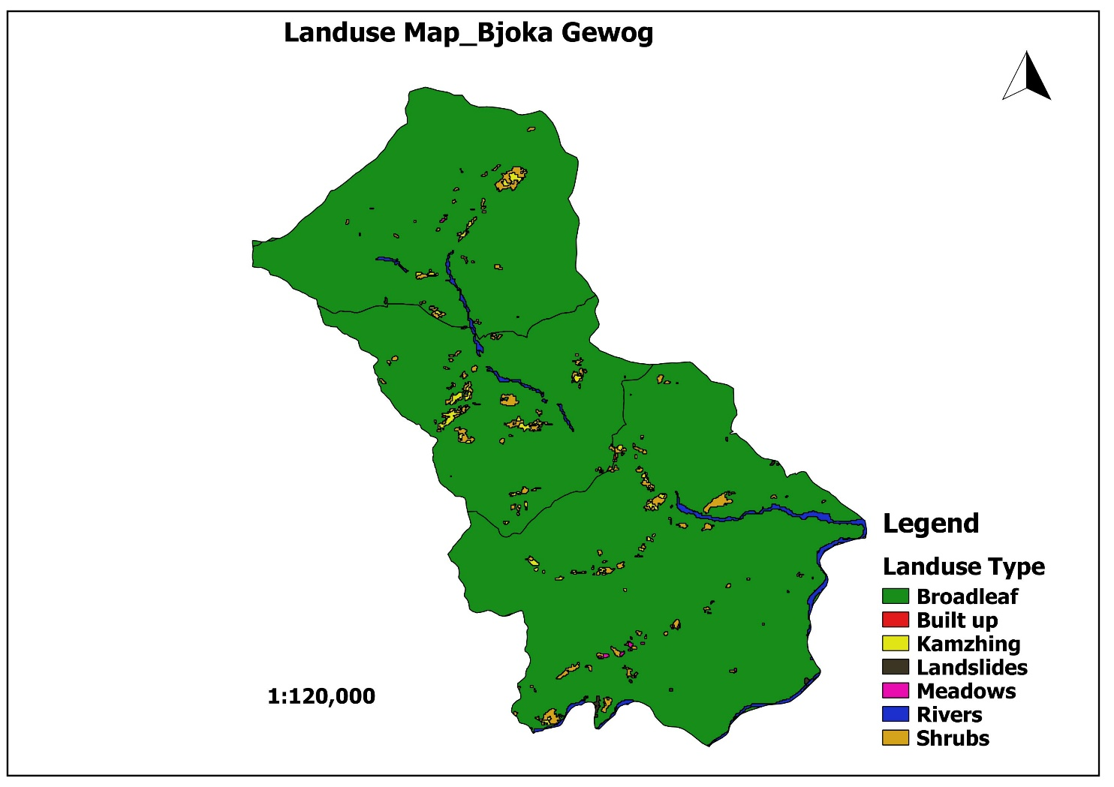
Figure 1: Land use map of Bjoka gewog

History of Forest
The Bjoka communities have managed and depended on the forest and its resources especially the Yula and cane for many generations. They have sustained their livelihood through the utilization of a wide range of forest produce as this practices continued over the years. It was observed over the years that the forest resources are getting declined from the biotic pressure as well as from the increasing of population. The resources particularly Yula and Cane have declined as compared to their availability in the past years. Driven by commercialization, the availability trends of these resources has decreased over the times and the communities have realized that these resources would reach to vulnerability if due attention is not given. In order to manage the resources on sustainable basis the group was formed to manage both Yula and Cane resources.

Formation of Management Sub-Groups
Given the different collection areas for the village, the whole CF management group has been divided into five sub-groups based on present structure of chiwogs delineated by the government.
Table 1: Detail of Sub-Group with village and households
Sub-group | Village | Number of households
Trong | Remadu | 8
 | Kamalahung | 33
 | Trong | 17
Kamati | Kamati | 20
 | Dalibi | 5
 | Pramaling | 6
Barpong | Barpong | 9
 | Namergang | 21
Chapdhempa | Chapdhempa | 16
 | Zarkabla | 5
Dali | Dali | 29
 | Kumari | 4
Total |  | 173

Block descriptions
A total of five sub-groups for Yula and Cane collections were identified under the five chiwogs namely Trong, Dali, Barpong, Chapdempa and Kamati of Bjoka Gewog for the resource inventory. Total of 55 collection sites for Yula were mapped using reference GPS (Global Positioning System) data collected from field and Google Earth™ high-resolution imagery. Upon mapping it was found that 3 cane sub-blocks and 10 Yula sub-blocks shared their boundaries outside Bjoka Gewogs either entirely or partially (towards Ngangla Gewog for the collection areas designated for Bjoka Trong Chiwog and towards Gongdue Gewog, Mongar Dzongkhag for the collection areas designated for Kamati Chiwog)

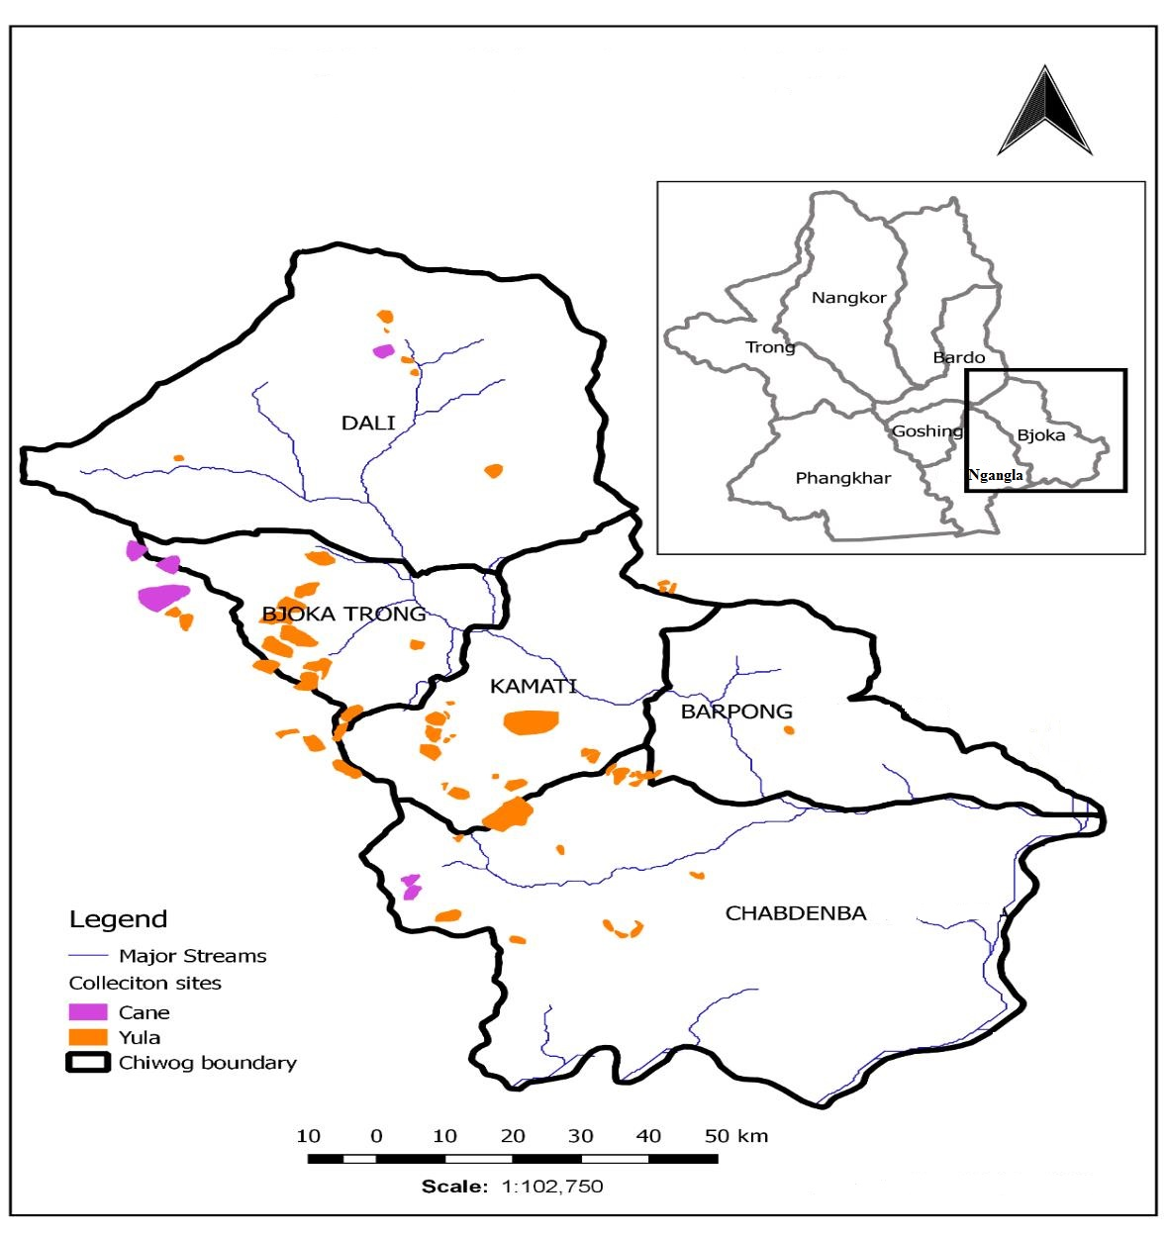

Figure 2: Yula and Cane collection area showing chewog boundary as block

Brief description of Yula
Yula is a local name of Neomicrocalamus andropogonifolius. It is a climbing bamboo, which has very smooth culms less than two centimeters in diameter with long shiny internodes. The culms can reach a length of eight to nine meters long. The species has been found in warm broadleaved forests at an altitude range of 400-1350masl.

Management of Yula
The Yula growing area managed by Bjoka community is spread all over the entire gewog in patches. However, the area to be managed by different communities is selected depending on the nearness to each village. The area identified for Yula management is based on their access to collection site in the past. No boundary issue has occurred amongst different villages of the group. For the assessment of resources in the collection block, it was based on boundaries of each chewog. For management purposes the forest has been divided in different sub-groups based chewog boundaries.

Description of Sub-Group
The whole CF is divided into sub-groups for the management and collection of Yula. The following are the sub-groups based on each village.

Trong Sub-Group
Trong sub-group consist of 58 households and the collection area and nearest walking distance from the village are given in the table 2.
Table 2: Trong Sub-Group with collection area and distance from village
Village | Collection Area | Distance from village
Remadu | Zawangtoe | 0.5 hours walk
 | Magangchu | 1 hours walk
 | DungdungJaimo | 0.5 hours walk
 | Chumogonpa | 0.5 hours walk
 | Retoe | 1 hour walk
 | Chenangre | 0.5 hours walk
Trong | Wamlathang | 3 hours walk
 | Poikarplam | 2 hours walk
 | Limdi | 0.5 hours walk
 | Zawang | 1 hour walk
 | Rongdu | 1 hour walk
 | Plam | 2.5 hours walk
 | Lungterpong | 0.5 hours walk
 | Toebechu | 1.5 hours walk
Total

Kamati Sub-Group
The group consists of 31 households from three villages, namely Kamati, Dalibi and Pramaling. These three villages are quite scattered from each. The table below shows the forest area identified to be managed by the three villages.
Table 3: Kamati Sub-Group with collection area and distance from village
Village | Collection Area | Distance from village
Kamati | DuentshoBorang | 1 hour walk
 | Kupithang | 1.5 hour walk
 | Talamtoe | 0.5 hours walk
 | Nyenthungri | 2 hours walk
 | Sheleti | 2 hours walk
Dalibi | Kurteola | 0.5 hours walk
 | Nyenthungri | 0.5 hours walk
 | Phagpakar | 2 hours walk
 | Wamlathang | 3 hours walk
 | Charshepong | 2 hours walk
 | Rawe | 3 hours walk
 | Kakala | 2.5 hours walk
Pramaling | Sumtungla | 4.5 hours walk
 | Karchungang | 2 hours walk
 | Bomo | 2 hours walk
Total

Barpong Sub-Group
The Yula management group at Barpong consists of 30 households from two villages, Barpong and Namergang. These two villages are one hour walk away from each other. The table below shows the blocks to be managed within this group.
Table 4:Barpong Sub-Group with collection area and distance from village
Village | Collection Area | Distance from Area
Barpong | Norlam | 1 hour walk
 | Wagomdrak | 1 hour walk
 | Phuimunang | 1.5 hour walk
 | Thrimapong | 0.5 hours walk
 | Nyerizompa | 2 hours walk
 | Bakaling | 0.5 hours walk
Namergang | Shokphu | 3 hours walk
 | Sangmarplam | 0.5 hours walk
 | Durduri | 2.5 hours walk
Total

Chapdhempa Sub-Group
This sub-group is the farthest village of Bjoka Gewog. It is located in the southern part of the Gewog. The group consist of 21 households from two villages of Chapdhempa and Zarkabla. It takes a day to reach the village from the Gewog center. The households in this village are scattered requiring three to four hours walk. The village is famous for production of both Yula and Cane products. For the production of Cane products, they mainly use Plectocomia himalayana. The table below shows their Yula growing area identified for the management.
Table 5: Chapdhempa Sub-Group with collection area and distance from village
Village | Collection Area | Distance from village
Chapdhempa | Gagenbrangsa | 2.5 hours walk
 | Kodongphey | 1 hour walk
 | Lawashong | 1 hour walk
 | Bardhang | 1.5 hours walk
 | Komdrak | 2 hours walk
 | Ngawaron | 1.5 hours walk
 | Wagomdrak | 2 hours walk
 | Chirpula | 3 hours walk
 | Nurku | 3 hours walk
 | Sengpari | 2.5 hours walk
Total

Dali Sub-Group
This group consist of 31 households from Dali and Kumari village. The village is three hours walk from Gewog center. This is also an isolated village located in extreme north of the Bjoka Trong.
Table 6: Dali Sub-Group with collection area and distance from village
Village | Collection Area | Distance from village
Dali | Redhingdoka | 1 hours walk
 | TokpalaGonpa | 2 hours walk
 | Nyewabrangsa | 1 hour walk
 | Arazang Lam | 1.5 hours walk
 | Chang Chang | 3 hours walk
 | Aungkhey | 2.5 hours walk
Kumari | Charshingpong | 2 hours walk
Total

Demand Assessment of Yula
The demand assessment of Yula in each sub-block and villages were assessed and the total requirement of backloads of Yula in a year is as shown in table 7.
Table 7: Demand assessment of Yula
Name of Group | Village | No. of H/H | Quantity (Backloads)
Trong | Remadu | 8 | 170
 | Trong | 17 | 213
 | Kamalahung | 33 | -
Kamati | Kamati | 20 | 139
 | Dalibi | 5 | 33
 | Pramaling | 6 | 40
Barpong | Barpong | 9 | 96
 | Namergang | 21 | 131
Chapdhempa | Chapdhempa | 16 | 196
 | Zarkabla | 5 | -
Dali | Dali | 29 | 311
 | Kumari | 4 | 25
Total |  |  | 1354

Annual Harvest Limit (AHL) of Yula
The following table shows the name of the sub group along with the number of back loads to harvest of Yula annually;
Table 8: No. of back load of Yula for harvest
Sl. No. | Village | No. of back load for harvest | Remarks
1 | Champdhempa | 91.71
2 | Namargang | 21
3 | Barpong | 106.61
4 | Dali | 54.88
5 | Kumari | 42.04
6 | Kamati | 62.57
7 | Dalibi | 168.90
8 | Pramaling | 14.99
9 | Ramadu | 463.09
10 | Trong | 420.21
Total |  | 1446.00

Comparison of Demand and AHL of Yula
The resources available in the forest within the CF will be able to meet the annual demand of Yula for the Bjoka Gongphel Tsharzo Tshogpaduring the current management plan period. The demand and AHL comparison can be easily refer in the table 7 and 8. Annually, the group will have excess of 92 backloads of Yula from the CF. However, the group should limit their annual collections as per the quantity they have reflected during the demand assessment.

Yula harvesting guidelines
The following harvesting guidelines should be followed to sustain the Yula resource base;
- Harvesting should be limited to one, two year-old or older culms (when culms produce second shoot (branch) at the top.
- Harvest culms only from clumps that have more than five culms.
- Two to three young (one to two-year old) culms should be maintained in each clump to favour more shoot regeneration in the following season.
- Culms should be harvested between December and May (the growth of Yula shoots is hampered if younger culms are damaged. Therefore, the Yula area should not be visited during the rest of the year).
- Livestock should be kept out of the growing areas of Yula especially during the period from May to November; presence of cattle will stunt the growth of young shoots.
- Yula will be collected twice a month which will be coordinated by Resoop of the village.
- The user group members will decide the date and collection rotation to different block in meeting. However, the Resoop of the village will be responsible to organize meeting.
- Collection will be done by moving in group. However, there is no limit for number of people from each household.
- The Resoop with a help of o to three user group members of each village will monitor the collection.

Management of Cane

Brief descriptions of Cane

Calamus acanthospathus

C. acanthospathusgrows in dense warm broad leaf forest at an altitude of 900-1900masl and has stems of 20 min length or more. It has a single stem species and it flowers from March to July and fruits in November to February. It is called Tsim in Dzongkha, Minji in Sharchop, Krath in Kheng, Moo in Monpa, and Pukka bet or Gowri bet in Nepali.

Plectocomia himalayana

C.latifoliusgrows in sub-tropical lowland forest at an altitude up to 700m. It flowers in April and has two to three stems. It is called Dray in Sharchop, Khran in Kheng, Pangkha in Monpa and Putle bet in Nepali.

Plectocomia himalayana

P. himalayanais a genus of flowering plant under Arecaceae family. It is a spiny, evergreen, climbing palm producing a cluster of stems that can climb high into the surrounding trees. It grows in warm broadleaf forest at an altitude between 1200 – 2150masl and has stems of 15m in length or more. It has a single stem but lateral shoots can come up from base and main stem. The flowering season lasts from August to December, while fruiting occurs in April. It is called Patsha in Dzongkha, Phashey in Sharchop, Ray in Kheng and Gowri bet, Torki bet and / or Tara bet in Nepali.

Harvesting guidelines for cane stems
- Harvest canes when mature. The maturity of cane can be recognized by a number of features:
- Loosening of leaf sheath/peeling of the “bark” of the cane
- Exposure of the lowest part of the stem
- The cane colour turns yellowish-reddish along the entire cane length.
- An estimated cane length of 15 m (or usable length of about 10 m).
- Harvest during winter as canes have a better quality during this season (lower water content and more durable).
- Do not harvest over-matured canes of Calamus acanthospathus as they are not suitable for handicraft purposes but these canes are forthe production of seed.
- Harvest over-matured canes of Plectocomia himalayana and Plectocomia himalayana to stimulate the regeneration of new shoots.
- Select about 10 cane plants (including both male and female plants) of the same species to be retained as seed canes per acre.

Harvesting guidelines for cane shoots from Plectocomia himalayana only
- Collect only cane shoots from Plectocomia himalayanaand not from other cane species.
- Only collect/use the shoots from lateral shoots, do not cut the main cane stem for shoot collection.
- Cut shoots from canes that have no physical support for further development (canes growing horizontally over the forest floor).
- Cut young shoot by bending the cane stem with the help of a long and strong stick with a hook.
- Cut the lateral shoot with a sharp knife diagonally (not straight in order to avoid rotting of the remaining stump). Take care to avoid damaging sucker buds (this will later develop into lateral shoots).
Furthermore, canes should be harvested according to the following procedures;
- Do not fell trees providing support to canes.
- Pull down as much of the cane stem as possible from the supporting tree in order not to waste resources left on the tree.
- Do not uproot or damage the rhizome, and cut cane stems above the sprouts in case of Plectocomia himalayana.
- Cut only lateral cane stems of Plectocomia himalayana.
- Do not uproot or damage the rhizome of Plectocomia himalayana.

Location and boundary
There are about six species of Cane available in the gewog and out of which the farmers use mostly two species i.e. Calamus acanthospathus and Plectocomia himalayana. Although, the use of the two species is much higher than other species, its disturbance is only in limited area. Calamus acanthospathus is found in four locations of the Gewog: Sethang, Kangbu, Golapathorcho and Arazang. Kangbu and Sethang are located in the borders of Bjoka and Ngangla Gewog. It takes three hours walk to reach to Sethang from Bjoka Trong.
If well protected, the same species will be available in future from Wamlathang, Shokphu and Sangling Ongpa as young seedlings were observed during Yula inventory work. However, due to slow growing nature, it might be harvestable only after 20 to 30 years.
Therefore, the main long term objective for the management of Cane is to recover the resource, by reducing the harvesting intensity to the minimal sustainable requirements. The Kangbu block is quite near to villages of Remadu and Trong (one back – load of Cane can be collected from this area in one day). Golapathorcho and Arazang are located in the northern part of the Gewog, near the border of Mongar Dzongkhag.
On the other hand, Plectocomia himalayana is found at Sangayborang, Praley and Paibangpong, in the southern part of the Gewog at lower altitude. This species is only collected by villagers from Chapdhempa.

Sub Group for Management of Cane
Similar to the case of Yula(for which the CF group has been divided in sub-group according to their collection sites)the same group has also been divided in two sub-groups for the collection of Cane: one for management of Calamus acanthospathus and one sub-group for management of Plectocomia himalayana. The Cane management group for Calamus acanthospathus constitutes of Trong, Kamati, Barpong, Chepdhempa and Dali. The group formed at Chapdhempa is for the management of Plectocomia himalayana. This group is famous for producing Cane baskets for which the particular Cane species alone is used.

Demand Assessment of Cane
The demand assessment of Cane was carried out based on the actual quantity that each Sub Group and villages required annually. The annual demand for cane is calculated based on the numbers of household in each villages and then club for each sub-group as shown in table 9.
Table 9: Demand assessment of Cane by each sub-group
Name of Sub-group | Village | No. of H/H | Qty. (No. of backload)
 |  |  | (C. acanthospathus) | (C. latifolius) | (P. himalayana)
Trong | Remadu | 8 | 18 | - | -
 | Trong | 17 | 20 | - | -
 | Kamalahung | 33 | 35 | - | -
Kamati | Kamati | 20 | 30 | - | -
 | Dalibi | 5 | 9 | 40 | 35
 | Pramaling | 6 | 12 | - | -
Barpong | Barpong | 9 | 18 | - | -
 | Namergang | 21 | 38 | - | -
Chapdhempa | Chapdhempa | 16 | 16 | 38 | 40
 | Zarkabla | 5 | - | - | -
Dali | Dali | 29 | 40 | - | -
 | Kumari | 4 | 9 | - | -
Total |  |  | 245 | 78 | 75

Annual Harvesting Limit (AHL)of Cane
The number of back load that are available for harvesting from each sub-blocks were calculated based on number of stems of Cane, total number of back loads in each block and then divided by the duration of plan period (10 years). The detail of stems in each block and backloads available are shown in the annexure II.
Table 10: AHL of different Cane species in back load
Collection area | AHL (No. in back load)
 | C. acanthospathus | C. latifolius | P. himalayana
Jatsapaiplam | 3.6 | 2.7 | 5
Sethang | 14 | 17 | 17
Kangbu | 10 | - | 12
Golapathorcho | 2 | - | 2
Praliyea | - | - | 25
Sangayborang | - | - | 6
Total | 29.6 | 19.7 | 67

Comparison of Demand and AHL of Cane
The comparison of demand and AHL of Cane species is shown in the table 11.
Table 11: Demand and AHL comparison of Cane
Sl # | Cane species | Demand (Backload) | AHL (Backload) | Difference (Backload)
1 | C. acanthospathus | 245 | 29.6 | -215.4
2 | C. latifolius | 78 | 19.7 | - 58.3
3 | P. himalayana | 75 | 67 | -8.0
Total |  | 398 | 116.3 | -281.7

The annual demand by the member exceeds the resources available in the forest as shown in the table 11.The group members should strictly follow their collection quantity as per the AHL of respective species. If members collect the quantity exceeding AHL, there is risk of total depletion of cane resources in near future. The group members should manage and enhance the existing group nursery for production of mass seedlings of Yula and Cane and then carry out the plantations in the degraded and open areas to fill the current gap between the demand and resources available in the CF.

Rules for collection and management of Cane
- The collection will be done by moving in group. This is to ensure equal distribution of cane loads from different blocks.
- The date for the collection of Cane from forest area will be declared by management committee of the group.
- Cane will be collected twice a year. First round in ninth and second round in third of Bhutanese month.
- Canestem that can be pulled down from tree top will be cut. They are not allowed to harvest Cane without examining the extend stretch of Cane on tree top.
- Only the Cane stem that are more than 10 meters long can be cut.
- In the Yula blocks where there is regeneration of Cane, grazing is restricted for five years.
- If anyone from the group doesn’t go for collection on the stipulated time framed by the group, they will miss one phase of collection.
- From each house hold, maximum of two persons will go for collection.

Work Plan and Timeline
The group will strictly follow the schedule of work plan in the time line reflected in table 12.
Table 12: Monitoring and Work Plan
Objective | Activity | Indicator | Responsibility | Timeline (Year)
 |  |  |  | 1 | 2 | 3 | 4 | 5 | 6 | 7 | 8 | 9 | 10
To ensure the sustainability of Yula and Cane resources through proper management prescriptions. | Awareness program on harvesting techniques before collection season | Report produced | Executive committee member and ZFD
 | Management of existing nursery. | Production of seedlings (2000/every after 2 years) | Chairperson and ZFD
 | Plantation of Yula | 5 nos. of seedling planted by each household | Chairperson/CFMG member/ZFD
 | Plantation of Cane | 5 nos. of seedling planted by every household in a year | Chairperson/CFMG member/ZFD
 | Patrolling | Conduct patrolling 5 times in a year. | Executive committee and ZFD
To enhance the livelihood of community through sale of Yula and Cane products. | Product design and price fixation | Product designed | Executive committee member
 | Sale of products | The record of income generated by group | Executive committee member

Monitoring and Evaluation
In order to ensure the group is carrying out the planned activities in line with the management plan;
- The Zhemgang Forest Division will carry out the monitor of CF annually and submit detail report to the Social Forestry and Extension Division (SFED).
- The mid-term review will be done in the fifth year and the final evaluation will be done towards the end of management plan period.

Part II: Community Forest Management By-Laws

Membership Arrangements
All the households residing in Bjoka Gewog and traditionally making use of Yula and Cane are eligible for membership in the management group.
Any household having census record in the gewog and intending to become new members are allowed to join the group. However, acceptance in the group will be made only through the consensus drawn in general assembly.

Procedures for becoming a new member
- He/she will apply in writing of his interest of becoming a new member to the Chairperson.
- Chairperson will discuss with CFMG members during meeting for confirmation of new membership.
- He/she will be a new member of the CFMG if it is agreed by CFMG members.
- Upon acceptance by the group, the new members shall contribute sum of Nu. 150 or equivalent as membership fees for the first three years).

Executive Committee Member Formation
The executive committee will comprise of 11 members. The committee should be formed with at least one member representative from each village. There should be nine males and two females in a committee member.
- Any member from the user group has right to contest for committee member.
- Committee members shall be selected through voting during the general meeting.
- The tenure of executive committee members shall be for the period of 3 years. However, if a committee member do not fulfill his/her Terms of Reference (ToR), misbehave and threaten the CFMG’s network, he/she shall be immediately replaced and be deprived of such opportunity in future.
- If the committee members have worked positively towards betterment of CFMG, he/she shall be re-elected. This is to reward the individual for his/her dedicated service to the group.

Procedures for selection of executive committee members
- Committee members will be selected through voting during the general assembly. The elected committee member’s tenure is for 3 years. However, if committee members misbehave and causing general inconvenience, s/he will be expelled from committee member and new members will be elected through voting.
- If committee members have done good work for the group, he can stand for re-election as a reward for his dedicated effort shown to the group.
- If committee members wishes to step down from his or her post due to domestic problem it will be accepted. However, investigation will be conducted at least with a team of committee members for obligation related to group and present to the user group. Based on their presentation the user group members will decide and grant approval of his resignation.

Criteria for selection of executive committee members
Any members from the user group has right to be a committee member. However they should meet the following criteria.
- Should be literate enough to maintain records.
- Should have experience of mobilizing the user group.
- Should have experience to deal with outsiders.
- Able to explore market for the products

Roles and Responsibility of Executive Committee Members
- They should work for the benefit of the group.
- Procure and provide tools and equipment required for bamboo crafting and other activities related to cane and bamboo product development.
- Develop new design and train other artisans to achieve mass production of particular product.
- Explore market for the product.
- Prepare plan for the group-specially for plantation of Yula, training and marketing of products.
- Coordinate with relevant offices for cane and bamboo resource development, training and marketing.
- Report work progress to relevant offices and Gewog Yargay Tshogchung.
- Prepare management plan, by-laws and present to the group to draw general consensus and submission to Dzongkhag administration, to seek approval from government.
- Make changes in management plan in consultation with user group members. However they should forward the copy of new changes made to the Zhemgang Forest Divisional Office

Terms of Reference (ToR) for CF Executive Committee Member
The following are the terms of reference for the management committee members;

ToR for Chairperson
- Planning of CF activities and discuss with the user group members.
- Coordinate meetings and activities.
- To liaise with other stakeholder regarding activities of a group.
- Coordinate the meeting and attending it.
- Approval and issue of permits.
- Distribute forest resource equally among user group member.
- Explore market for the medicinal plants available in CF area.
- Joint signatory with treasurer for the withdrawal of cash required for group activities from bank.
- Provide copy of minutes of meeting to the Beat office, Bjoka, Gewog and coordinate with different offices in implementation of group’s activity.
- To solve the conflict that arises within the group or with outsiders.
- Explore market for the products.

ToR for Secretary
- Officiate as chairperson in absence of chairperson.
- Write official correspondences.
- Provide assistance to the chairperson for smooth functioning.
- Maintain records of any activities carried out by the CFMG and products received from each cluster.
- Maintain minutes of meeting.
- Write progress report and submit to the chairperson.
- Instruct and assist treasurer in maintaining of cash book.
- Explore market for the products.

ToR for Treasurer
- Maintain financial transaction record.
- Submit expenditure and cash balance report to the chairperson and also present it to CFMG during the meetings.
- Take care of rolling fund maintained at Gewog.
- Collection of fees from group members.
- Issue money receipt after collecting fines from the defaulters.
- Maintain deposit and withdrawal account.
- Maintain accounts of monthly payment made to members from each clusters.

ToR for Resoop
- Conduct patrolling and keep vigilance if any illegal cutting of both Yula and Cane are happening in the CF.
- Be alert and report to chairperson if any selling of products to middle men are found (All members have agreed not to sell products to any middlemen, but only through the CF group itself).
- Report illegal offences to the chairperson.
- Collect discussion points from the group members to prepare agenda and distribution of minutes of meeting to CFMG.
- Maintain records of cane and bamboo products collected from each household and delivery to the sale counter.

Roles and Responsibility of CFMG members
- The other members shall assist Resoop whenever he/she approaches.
- Implement activities per the management plan.
- Protect CF from illegal activities and refrain from doing illegal activities.
- Abide CF Management Plan and By-laws.
- Attend ad hoc meetings as conveyed by Resoop.
- Provide any Cane and Yula products to the group.
- Inform Resoop about availability of products in their houses.
- Improve quality of products to get better price. However, they will have right to increase price after every two years.
- Keep cattle away from Yula plantation area.
- Avoid extraction of timber from Yula growing and plantation area.
- Carry out plantation of both Cane and Yula.

Compensation to Executive Committee Members
As an incentive for the responsibilities shoulder by the management committee members, they will be paid the compensation through the sale of products as reflected below;
When the individual CFMG member deposit the product to the collection center, the management committee members will pay the price of the product to the individual members. When the product is sell to the customer, the price of the product will be fixed with addition of 30% to the cost of the product price paid to the individual CFMG member. From the added cost of 30%, 15% will be deposited to the Group joint account and remaining 15% will be equally divided amongst the management committee members (Chairperson 5%, Secretary 5% and Treasurer 5%) as compensation.

Fines and Penalties

Penalties and Fines for Yula
- If any member sells the product to the middlemen, he/she shall pay 50%of his sale proceeds to the group.
- Ifs/he collect the Yula during the ban period, a fine of Nu.1000/= per backload shall be levied.
- During the collection period if s/he collects without consulting the other group members, a fine of Nu.500/=shall be imposed for a backload.
- If anyone is absent during working days he/she shall pay Nu.500/=
- If anyone is absent during meeting, s/he shall pay Nu.500/= as fine. They must be present during start time and joining the group after that will be considered as absent liable of payment of penalty.
- If members are absent during meeting s/he should pay a fine of Nu.500/=per day. They must be present during starting time of the meeting and up to ten minutes will be considered based on genuineness of their reason for late. If joins after 10 minutes it will be considered as absent for the whole day.
- If cattle are found grazing inside Yula growing area, a fine of Nu.200/= per cattle shall be imposed.
- If anyone extract/cut trees from Yula growing areas without valid permit s/he shall pay a fine as per FNCRR.

Penalties and Fines for Cane
- If anyone violates rules for the management of Cane, the defaulter will pay a fine of Nu. 500/back load as penalty.
- For the collection of Cane, members should move in groups coordinated by Resoop. No one is allowed to collect Cane by moving individually.
- If anyone cuts Cane that are lesser than 10 meters, they should pay fine of Nu.300 per piece.
- If outsider (other than Bjoka people) collects Cane from the area identified for management, they should pay fine as follow.
- 1st time Nu.500/backload-; 2nd time Nu.1000/backload-; 3rd time Nu.1500/backload-
- If anyone leaves the group out of his wishes, they will be accepted. However, he/she has no right to claim for any benefits from the group and also cannot claim right for resource collection from CF area although he is a Bjokapa.

Financial Arrangements
The fund for the group will be raised through the following means;
- Membership fees.
- Collection of fines and penalties.
- Interests earn from the bank.
- Donations made by the outsiders.
- Fund will be managed by opening a saving account with financial institution based in Panbang. It will be open as joint account of the CFMG and operated with joint signatory of chairperson and treasurer.
- The deposit f cash to the joint account can be made by any member whoever proceed to Panbang. However, the treasurer shall ensure to collect the counter foil of deposit and maintain in proper file for future record.
- To meet the day to day expenses and meet payment for product suppliers the group will maintain Nu. 200,000 (Two hundred thousand) only jointly with the Treasurer and Chairperson.
- The fund will be mainly used for operation of group’s activity like procuring of tools, equipment and other materials required for production of Yula and Cane products.
- The fund will also be used for buying of products from CFMG members.
- To meet daily cost for running the community forest office and in transporting of products from Bjoka to other areas.

Benefit Sharing Arrangements

Arrangements for benefits to poor households
- Once the group has accumulated fund of Nu.500, 000/= (Five hundred thousand) in saving account, the group will provide support to poor people in the group. The support will be provided in following field. Poor household/people will be selected after forming committee.
- Supply of CGI sheets for roofing their house.
- Support the disadvantage family with Nu. 3,000/= (Three thousand) when accident occurs and the person become disabled.
- If the house of people identified as poor is completely damaged, they will be given a grant of Nu. 10,000/= (Ten thousand) to meet expenses in construction of temporary shade.

Other benefit sharing arrangements
- The excess amount will be deposited in the joint bank account and will be given loan to the group members at interest rate lower than the financial institutions.
- Any registered member of Bjoka Tsharzo Gongphel Cane and 54 collection sub-blocks for Tshogpa is eligible to apply for loan of Nu.20, 000/= (Twenty thousand). However, it will be discussed and decided in the committee meeting.
- For expenses incurred in day to day functioning of the group if monthly expenditure is less than Nu. 3000/= it shall be approved by chairperson, secretary and treasurer.
- If the expenditure is between Nu. 3000/= to Nu. 5000/= it shall be decided in presence of 6 committee members.
- If the expenditure is more than 5000/= it shall be decided with presence of all committee members as well as one representative from each sub-group.

Meetings
- Executive committee members will meet quarterly.
- Meeting will be conducted only with presence of at least 8 members. If there are less than 8 members, it shall be postponed.
- If there is anything to be approved, it shall be approved with presence of committee members. The decision taken by one or two people in meeting will be treated invalid.
- If committee members should go to other place to perform group work, his expenses will be not collected from user group members. The expenses will be met from group’s fund.
- General meeting will be conducted once in a year (Within 20-25, November)

Conflict Management
If any conflict arise within the CFMG members, the chairperson will negotiate and solve it. If the case is not able to solve by the chairperson it will be brought to the forum of 11 management committee members. Even if the management committee members cannot be solved it will be brought to the Gewog Administration and if gewog cannot solve the conflict it will be forwarded to the Royal Court of Justice.

Amendment of CFMP and By-laws
In case the CFMG sees the need to make minor changes to the by-laws during the course of implementation of this management plan (such as addition or deletion of members and addition of points in by-laws), they can do so by conducting meeting and submitting relevant documents to Zhemgang Forest Division. However, for the major amendment of the by-laws, prior approval should be sought from the Department of Forests and Park Services.

Power of the Department
The Department of Forests and Park Services have right to take action as per the FNCRR, 2017 if the group violates the rules prescribed in the management plan.

Marketing of Products
- The sharing of Yula and Cane resources will be done as per the collection procedures mentioned in this plan.
- All Yula and Cane products will be marketed through the group.
- The user members are responsible to bring their products to the collection centers at Bjoka and sell the product to the group at jointly agreed price.
- From the collection center the committee members will take responsibility to market the products.
- The profit made from the sale of products will be deposited in group’s joint account.
- Price for the products shall be fixed in every two years through general meeting.

Procedures to bring products to collection center
- Individual households will inform the Resoop about the availability of the finished products for record.
- From the respective areas, the members will deposit the products at the collection center.
- The secretary will issue “received coupons” to those who submit the products.
- The owner shall proceed to the treasurer along with the coupon.
- Based on the receipts by secretary, treasurer shall make the payments for the products as per the quality and price fixed for it.
- The chairperson and secretary shall ensure to find good market and sell the products.
- At Gewog level, selling of products to outsiders will take place only from the weaving/collection center. At Panbang, products shall be sold from the show room.
- If the products need to be sold beyond Panbang, at least two office bearers have to be accountable for marketing.
- The Resoop, Secretary and Treasurer will keep detail records of collection and sale of products.
- All members have agreed that no one will sell their products individually to the outsiders. All products will be marketed through the group in order to achieve better bargaining.

Support required from other stakeholder
The following are some of the relevant stakeholders with its respective responsibility and support required by the CF.

Forest Beat Office, Bjoka
- Technical backstopping in propagation of Yula and Cane.
- Explore funding and conduct training in office management and record keeping.
- Monitoring of the group activities.
- Assist to explore market for the products.
- Auditing of groups’ accounts and activities quarterly.

Zhemgang Forest Division
- Provide technical backstopping to the group.
- Preparation of transit permit and handing over to the group.
- To carry out Auditing of group’s account annually.
- Monitoring of the group activities.

Dzongkhag administration
- Provide support in processing of loan for the group.
- Allot stall site for selling their products during Dzongkhag Tshogdu.
- Coordinate with other Dzongkhags to provide stall site for the group during their Tshechu.
- Provide transportation, to take products to other Dzongkhags.
- Inform group about the market information.
- Provide Gewog account personnel for auditing of groups account.

Gewog administration, Bjoka
- Resolve the conflicts that are not able to solve by the group in their meeting.
- Transportation of products to other Dzongkhags.

Dungkhag administration
- Provide the necessary support required by the group.
- Assist to explore market for the product.

Gewog Yargye Tshogdey
- Approve prices fixed for different products by the group.
- To solve conflicts that are not able to solve by the Gewog administration.
- Provide budgetary support in implementation of groups planned activities.

Tarayana Foundation
- Provide training in product diversification.
- Provide tools for craft work.
- Coordinate study tour for the group.
- Explore market for the products.
- Develop Pamphlets of the bamboo craft products and disturbance to other organization.
- Invite group for the sale of products during Trade fares and Expo.

Annexure I: CFMG Member List

Trong Sub-Group
Sl. No. | Name | CID No. | Village
1 | Mr. Sangay | 12002000826 | Trong
2 | Mr. Jambay | 12002001340 | Trong
3 | Mr. Choida | 12002001359 | Trong
4 | Mr. SangayWangdi | 12002001380 | Trong
5 | Mr. Changlo | 12002001397 | Trong
6 | Mr. Yeshi Dorji | 12002001424 | Trong
7 | Mr. Choejay | 12002001433 | Trong
8 | Mrs. Karma Zangmo | 12002001441 | Trong
9 | Mr. Wangda | 12002001457 | Trong
10 | Mr. Dorji Wangdi | 12002001474 | Trong
11 | Mrs.Choden | 12002001487 | Trong
12 | Mr.Katingla | 12002001498 | Trong
13 | Mr. Karma Tenzin | 12002001504 | Trong
14 | Mr.Wangdi | 12002001514 | Trong
15 | Mr.Kinzang Dorji | 12002001529 | Trong
16 | Mr.Leki Dorji | 12002001545 | Trong
17 | Mr.Gyeltshen | 12002001564 | Trong
18 | Mr.Thinley | 12002001578 | Trong
19 | Mr.Chophel | 12002001617 | Kamalahung
20 | Mr. Dorji Wangdi | 12002001655 | Kamalahung
21 | Mr. Napo | 12002001646 | Kamalahung
22 | Mr. Dorji Wangdi | 12002001635 | Kamalahung
23 | Mr.Pheshey | 12002001670 | Kamalahung
24 | Mr.Rinchen | 12002001683 | Kamalahung
25 | Mr. Karma Tenzin | 12002001687 | Kamalahung
26 | Mr.Sonam | 12002001701 | Kamalahung
27 | Mr.Lham Tenzin | 12002001710 | Remadu
28 | Mrs.TsheringChoden | 12002001729 | Remadu
29 | Mr.LekiTshewang | 12002001732 | Remadu
30 | Mr.Sangay Dorji | 12002001742 | Remadu
31 | Mr.SangayPenjore | 12002001748 | Remadu
32 | Mr.Wangda | 12002001757 | Remadu
33 | Mr.Lethro | 12002001765 | Remadu
34 | Mrs.NimaDema | 12002001771 | Kamalahung
35 | Mrs.UgyenChoden | 12002001777 | Trong
36 | Mr. Pema Tashi | 12002001783 | Trong
37 | Mr.LekiTshering | 12002001661 | Trong
38 | Mr.SonmaWangchuk | 12002001657 | Trong
39 | Mr.Jamtsho | 12002001750 | Remadu
40 | Mrs.Tshoden | 12002001753 | Remadu
41 | Mr.sherab | 12002001303 | Trong
42 | Mrs.TashiTshomo | 12002001311 | Trong
43 | Mr.Sangay | 12002001324 | Trong
44 | Mr.RinchenTshewang | 12002001070 | Trong
45 | Mr.SangayWangdi | 12002001633 | Trong
46 | Mr.Penjore | 12002001568 | Trong
47 | Mr.Sither | 12002001077 | Trong
48 | Mrs. Pema Sezom | 12002001554 | Trong
49 | Mr. Karma | 12002001553 | Trong
50 | Mr.TsheringWangdi | 12002000182 | Trong
51 | Mr.Tashi | 12002001799 | Trong
52 | Mr.TsheringWangchuk | 12002000260 | Trong
ChapdhempaSub_Group
1 | Mr.Namgay | 12002000897 | Chapdhempa
2 | Mr. Rinzin | 12002000930 | Chapdhempa
3 | Mr.Namgay | 12002000804 | Chapdhempa
4 | Mr.Tobgay | 12002000858 | Chapdhempa
5 | Mr.Wangda | 12002000419 | Chapdhempa
6 | Mr.Nedup | 12002000454 | Chapdhempa
7 | Mr.Jamtsho | 12002000496 | Chapdhempa
8 | Mr.Wangchuk | 12002000498 | Chapdhempa
9 | Mr.Ugyen Dorji | 12002000493 | Chapdhempa
10 | Mr.Tashi Dorji | 12002000906 | Chapdhempa
11 | Mr.Duba | 12002000396 | Chapdhempa
12 | Mr.SangayRinchen | 12002000439 | Chapdhempa
13 | Mr.SangayWangdi | 12002000431 | Chapdhempa
14 | Mr.Tshewang | 12002000456 | Chapdhempa
15 | Mr. Pema | 12002000351 | Chapdhempa
16 | Mr.SangayTshewang | 12002000358 | Chapdhempa
Barpong Sub-Group
1 | Mr. Dorji Wangdi | 12002000169 | Barpong
2 | Mr.Jamtsho | 12002000141 | Barpong
3 | Mr. Wangda | 12002000243 | Barpong
4 | Mr.KezangWangdi | 12002000243 | Barpong
5 | Mr.SangayWangdi | 12002000185 | Barpong
6 | Mr.LekiDhendup | 12002000217 | Barpong
7 | Mr.Damchoe | 12002000154 | Barpong
8 | Mr.Kinzang | 12002000296 | Barpong
9 | Mr. Dorji | 12002000078 | Barpong
10 | Mr. Pema Drakpa | 12002000198 | Namergang
11 | Mr.Samten | 12002000014 | Namergang
12 | Mrs. Dorji Dema | 12002000033 | Namergang
13 | Mr.Chethey | 12002000042 | Namergang
14 | Mr.Wangpo | 12002000062 | Namergang
15 | Mr.SonamJamtsho | 12002000080 | Namergang
16 | Mr. Karma Dorji | 12002000091 | Namergang
17 | Mrs. Pema Lhamo | 12002000022 | Namergang
18 | Mr. Karma Wangdi | 12002000110 | Namergang
19 | Mr.Sonam Dorji | 12002000116 | Namergang
20 | Mr.Nima Dorji | 12002000140 | Namergang
21 | Mr.Ugyen | 12002000221 | Namergang
22 | Mr.PhurbaWangdi | 12002000291 | Namergang
23 | Mr.Pemala | 12002000304 | Namergang
24 | Mr. Rinzin Dorji | 12002000930 | Namergang
25 | Mr.Rinchen | 12002000443 | Namergang
26 | Mr.Wangda | 12002000228 | Namergang
27 | Mr.SangayTshering | 12002000128 | Namergang
28 | Mr.Ugyen | 12002000119 | Namergang
29 | Mr.TandinTshewang | 12002000302 | Namergang
30 | Mr. Pema Tshewang | 12002000001 | Namergang
Dali Sub-Group
1 | Mr.Gembo | 12002000685 | Dali
2 | Mr. Dorji Wangdi | 12002000516 | Dali
3 | Mr. Choda | 12002000701 | Dali
4 | Mrs.Rinchen Lhamo | 12002000619 | Dali
5 | Mr.GanteyKodong | 12002000153 | Dali
6 | Mr.Thukten | 12002000415 | Dali
7 | Mr.ChechongTshering | 12002000391 | Dali
8 | Mr.Wangchuk | 12002000439 | Dali
9 | Mrs.Chezom | 12002000748 | Dali
10 | Mr.ThinleyWangdi | 12002000617 | Dali
11 | Mr.Kezang | 12002000319 | Dali
12 | Mr.Yeshi Dorji | 12002000630 | Dali
13 | Mr.NimaTashi | 12002000701 | Dali
14 | Mrs.KingaPem | 12002000610 | Dali
15 | Mr.JampelTshering | 12002000526 | Dali
16 | Mr.Lham Tenzin | 12002000586 | Dali
17 | Mr.Oundu | 12002000731 | Dali
18 | Mr.Dawro | 12002000679 | Dali
19 | Mr.Gyembo Dorji | 12002000732 | Dali
20 | Mr.LekiTshering | 12002000643 | Dali
21 | Mr.Thinley Dorji | 12002000765 | Dali
22 | Mrs.LekiDema | 12002000566 | Dali
23 | Mr.Ugyen Dorji | 12002000706 | Dali
24 | Mrs. Lhamo | 12002000653 | Dali
25 | Mrs. Dorji Dema | 12002000844 | Dali
26 | Mr.Thinley Dorji | 12002000777 | Dali
27 | Mr.Rinchen | 12002000686 | Dali
28 | Mr.Dargay | 12002000760 | Kumari
29 | Mr.Penjor | 12002000790 | Kumari
30 | Mr.Sangay Dorji | 12002000813 | Kumari
Kamati Sub-Group
1 | Mr. Pema | 12002001013 | Dalibi
2 | Mr.Pheshey | 12002001033 | Dalibi
3 | Mr.LekiTshering | 12002001060 | Kamati
4 | Mr.Nima Dorji | 12002001083 | Kamati
5 | Mrs. Dorji Dema | 12002001100 | Kamati
6 | Mr.Tshering | 12002001110 | Kamati
7 | Mr.Wangdi | 12002001122 | Kamati
8 | Mr.Kinzang | 12002001147 | Kamati
9 | Mr.NorbuJaipo | 12002001157 | Kamati
10 | Mr.Lhendup | 12002001176 | Kamati
11 | Mr..Leki | 12002001192 | Dalibi
12 | Mr.Yeshi | 12002001202 | Dalibi
13 | Mr. Pema Jaipo | 12002001210 | Dalibi
14 | Mr.Sangay Dorji | 12002001238 | Dalibi
15 | Mr.Thinley | 12002001250 | Pramaling
16 | Mr.PhuntshoWangdi | 12002001259 | Pramaling
17 | Mr.NorbuWangchuk | 12002001267 | Pramaling
18 | Mr.SonamWangdi | 12002001276 | Pramaling
19 | Mr. Karma Tshering | 12002000950 | Pramaling
20 | Mrs. Dorji Lhamo | 12002001278 | Pramaling
21 | Mr.SangayChunwa | 12002001104 | Kamati
22 | Mr.LekiWangdi | 12002001114 | Kamati
23 | Mr. Dorji | 12002001173 | Kamati
24 | Mr.Tagyel | 12002001236 | Kamati
25 | Mrs.SangayWangmo | 12002001286 | Kamati
26 | Mrs.Sonam Lhamo | 12002001225 | Kamati
27 | Mr. Pema Tshering | 12002000350 | Kamati
28 | Mrs. Lhamo Chunwa | 12002001073 | Kamati
29 | Mr. Dorji Wangdi | 12002001292 | Kamati
30 | Mr.Wangdi | 12002000431 | Kamati

Annexure II: Calculation of Annual Harvesting Limit of Cane

Sub-Block Name | Area  (Ha) | Cane species | No. of cane stem in block | Total No. of Back loads in blocks | AHL in back load
Jatsapaiplam | 43.06 | Calamus acanthospathus | 108 | 36 | 3.6
 |  | Plectocomia himalayana | 101 | 50 | 5
 |  | Plectocomia himalayana | 90 | 26 | 2.7
Sethang | 13.76 | Calamus acanthospathus | 428 | 143 | 14
 |  | Plectocomia himalayana | 343 | 172 | 17
 |  | Plectocomia himalayana | 343 | 172 | 17
Kangbu | 13.97 | Calamus acanthospathus | 349 | 100 | 10
 |  | Plectocomia himalayana | 349 | 116 | 12
Golapathorcho | 10.15 | Calamus acanthospathus | 101 | 20 | 2
 |  | Plectocomia himalayana | 100 | 22 | 2
Praliyea | 8.61 | Plectocomia himalayana | 287 | 253 | 25
Sangayborang | 6.72 | Plectocomia himalayana | 168 | 56 | 6

